**Code Review By Muhammad Abdul Rehman**

**MEAN stack developer Since end of 2018**

1 Application has Memory leaks which are not handle?

For Example

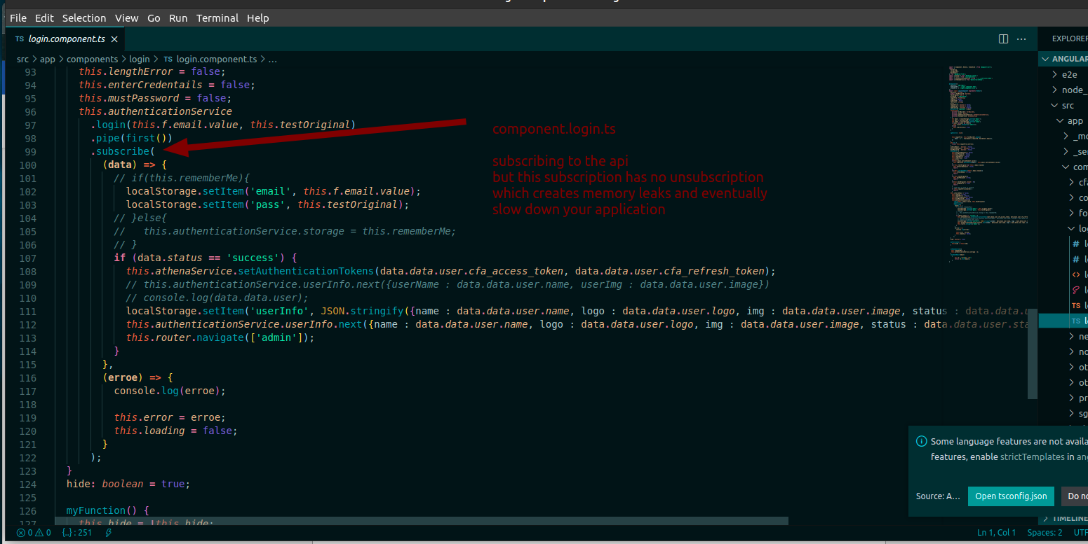

2 Extra Code:

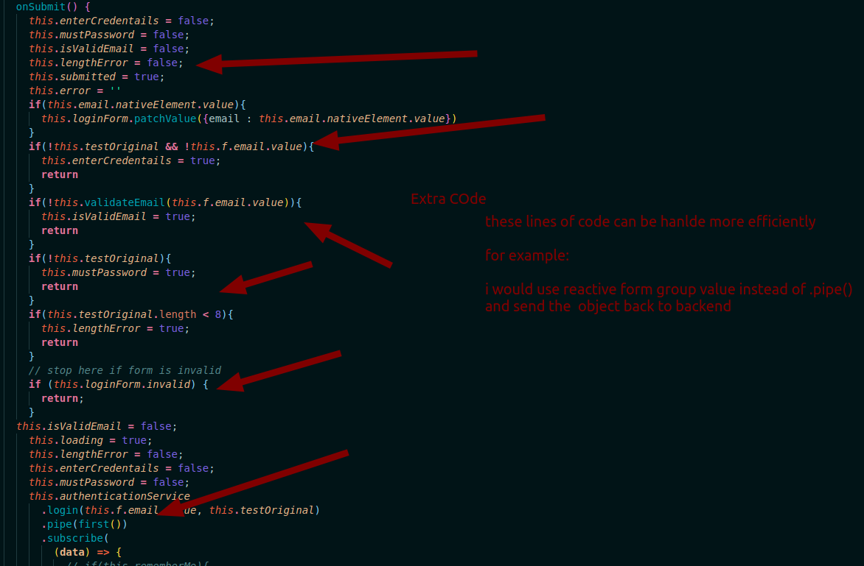

3 Error Handling in .subscription() is wrong.

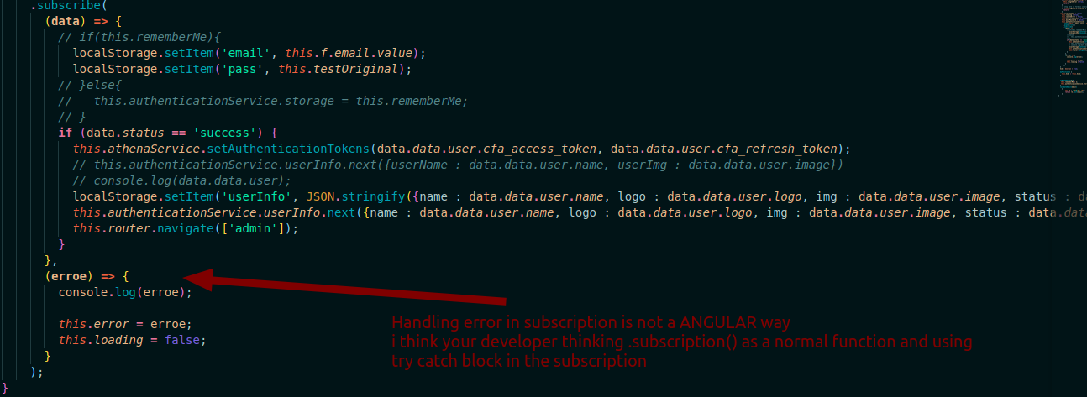

I am adding a reference of stack-over-flow to support my statement

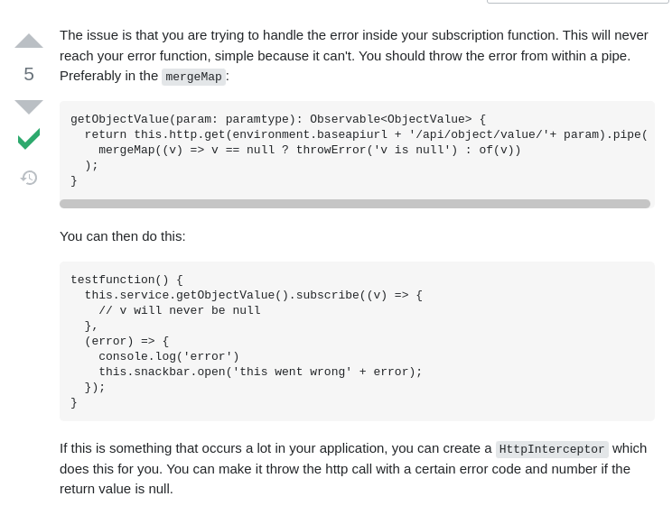

4 : app.routing.module.ts

Your way of protecting routes are ambiguous

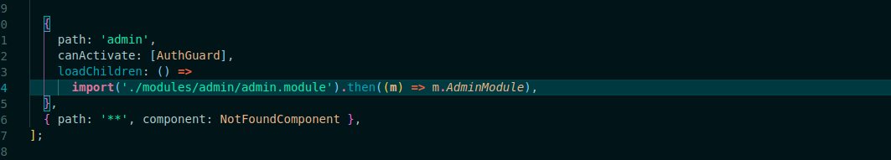

Instead of calling whole module in loadchildren you should pass a reference here.

5 Login function can be more optimized

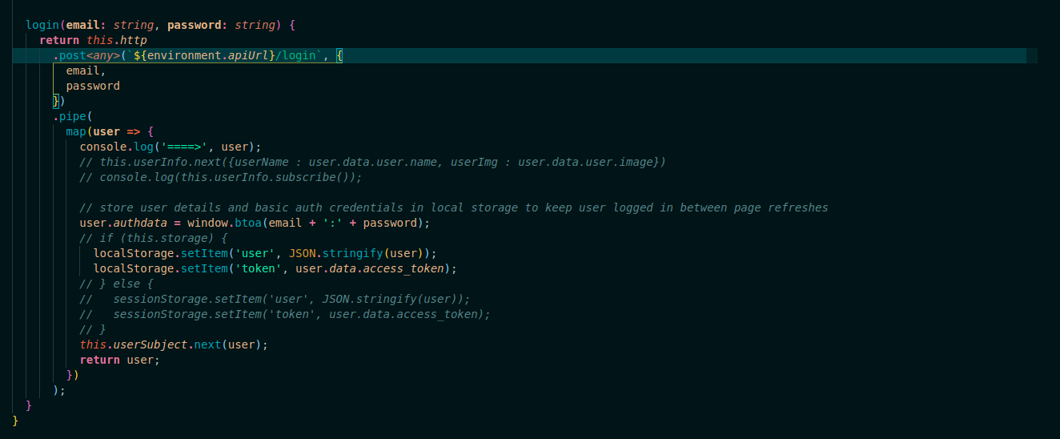

Well I can adding my loign fucntion as a reference here

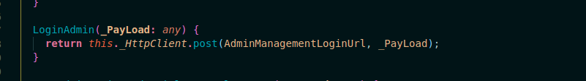

Simple and Precise isin it?

Why would I call pipe if I can restrict my data from my backend api what to send what to not?

6 : You folder Structure could be more self Explanatory

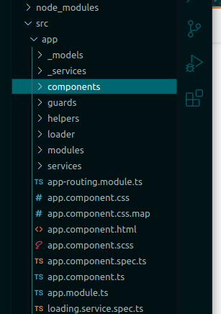

Well I agree that folder structure has nothing to do with your code optimization

But for your own readability or some other guy you have to create a self-explanatory structure.

For Example:

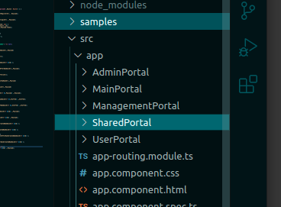/home/fazi/Desktop/Projects/angular/src/environments/environment.prod.ts

Now I have 4 main folders and everything is inside these is it not simple?

7 Api Url should be declare in separate file

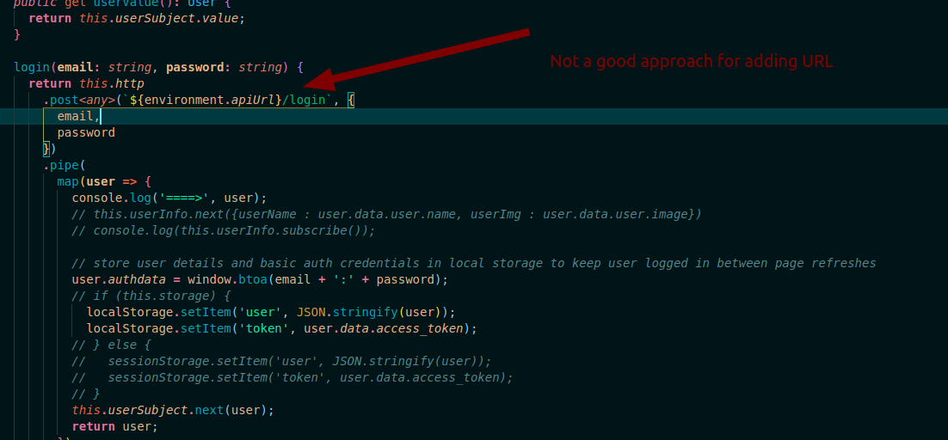

And my way of defining URLs

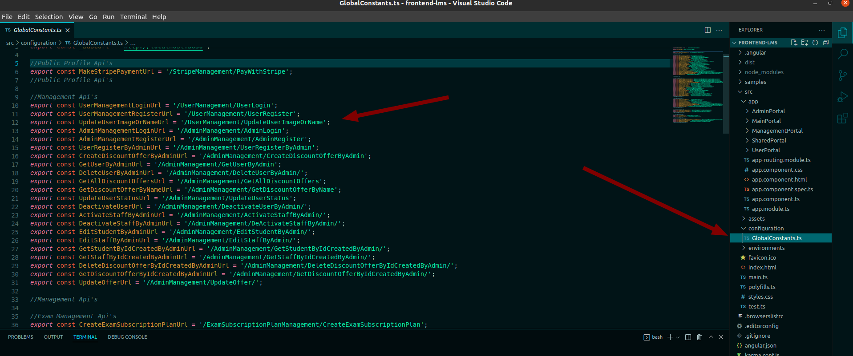

These are the major flaws I have come up with the code review.

**Some good things in your code.**

1 You have used Interface (which is very good approach)

2 Your code structure is good to some extent

3 You have used Directives for DOM handling